IoT-Based Gaming Console for the Education of Special Children

*Naveen A1*

*Departement of Computer Science and Engineering*

*Kalasalingam Academy of Research and Education*

*Virudhunagar ,India.*

[*99220040319@klu.ac.in*](mailto:99220040319@klu.ac.in)

*Dinesh Karthik M4 Department of Computer Science and*

*Engineering Kalasalingam Academy of Research*

*and Education Viruthunagar, India.*

[*99220040836@klu.ac.in*](mailto:99220040836@klu.ac.in)

*Smriti Sinha2*

*Departement of Computer Science and Engineering*

*Kalasalingam Academy of Research and Education*

*Virudhunagar , India.*

[*99220041372@klu.ac.in*](mailto:99220041372@klu.ac.in)

*Aathi Seshan P5 Department of Computer Science and*

*Engineering Kalasalingam Academy of Research*

*and Education Viruthunagar, India.*

[*99220040791@klu.ac.in*](mailto:99220040791@klu.ac.in)

*kalyaani M3*

*Departement of Electronics and Communication Engineering*

*Kalasalingam Academy of Research and Education*

*Virudhunagar, India.*

[*9922005337@klu.ac.in*](mailto:9922005337@klu.ac.in)

*6 Mrs. Syed Ali Fathima Department of Computer Science and*

*Engineering*

*Kalasalingam Academy of Research and Education*

*Viruthunagar, India* [*r.syedalifathima@klu.ac.in*](mailto:r.syedalifathima@klu.ac.in)

***Abstract*— This research paper presents the design and development of an interactive educational device aimed at enhancing the learning experience of children with intellectual disabilities, including those with autism spectrum disorder (ASD). The device integrates Near Field Communication (NFC) technology with a user-friendly interface to facilitate the learning of basic numeracy and literacy skills. The system consists of a display unit that shows a target number or alphabet, and NFC cards with corresponding stickers that children can place on the device. When the correct NFC card is placed, the device provides positive auditory feedback, such as “Congratulations”, reinforcing the child’s learning. In case of an incorrect placement, the device offers encouraging prompts to try again, fostering a supportive and motivating learning environment. The design leverages multisensory engagement—visual, auditory, and tactile—to cater to the diverse learning needs of children with intellectual disabilities. Preliminary testing with a small group of children demonstrated the device’s potential to improve engagement and learning outcomes. This study contributes to the growing body of research on technology-enhanced learning tools for children with special educational needs, highlighting the importance of interactive and adaptive technologies in promoting inclusive education. The findings suggest that such devices can be effective in teaching foundational skills while maintaining a fun and engaging learning experience. Future work will focus on expanding the device’s capabilities and conducting larger-scale evaluations to assess its long-term impact on learning and skill retention.**

***Keywords—*** ***Special education, Autism Spectrum Disorder (ASD), Near Field Communication (NFC), interactive learning, assistive technology, inclusive education, IoT in education, multisensory learning.***

1. INTRODUCTION

The integration of technology into special education has significantly advanced over the past decade, offering new pathways to engage children with intellectual disabilities in meaningful learning experiences. With the rise of digital tools and interactive platforms, educators now have access to an array of assistive technologies designed to accommodate diverse cognitive and developmental needs. Game-based learning has emerged as a particularly effective approach, with traditional and digital games helping to enhance movement, focus, and cognitive engagement among children with special needs. Studies highlight how physical games, like the Traditional Game Based Learning Model, can improve motor skills in mentally challenged children [1] while digital learning games provide opportunities to engage students with intellectual disabilities in educational tasks [2].

Recent advancements in game-based and interactive learning technologies have demonstrated promising results for special education. Systematic reviews consolidate evidence on the benefits of digital game-based learning, including improved motivation, attention, and skill acquisition [3] [4].

The incorporation of Augmented Reality (AR) and Internet of Things (IoT) in learning systems has shown potential to assess and stimulate both physical and mental activity in children with special needs [5]. Platforms using Near Field Communication (NFC) and Radio-Frequency Identification (RFID), such as those discussed in [6], effectively blend tactile and digital interaction, enhancing motivation and learning outcomes. Moreover, NFC-based educational games have been explored to bridge physical and digital learning environments while supporting student engagement [7].

Despite the increasing availability of digital tools in special education, many existing educational technologies fall short in meeting the unique learning needs of children with intellectual disabilities. Current solutions such as mobile apps and tablet-based learning platforms often lack tactile interaction, immediate feedback, and adaptive support tailored for cognitive or developmental delays. Furthermore, these solutions may be too complex for independent use by children with autism or mental retardation, and they rarely incorporate multisensory learning (visual, auditory, and tactile) in a way that sustains engagement and reinforces learning [8][9]. There is a notable gap in affordable, interactive, and easy-to-use learning devices that are specifically designed for children with intellectual disabilities and tailored to foundational literacy and numeracy development.

The primary objective of this study is to design and develop a child-friendly, NFC-based educational device aimed at facilitating foundational literacy and numeracy learning for children with intellectual disabilities. This research is guided by the following specific objectives:

1. To design and implement an interactive educational device that utilizes Near Field Communication (NFC) technology to support the acquisition of basic literacy and numeracy skills among children with intellectual disabilities.
2. To incorporate multisensory interaction—including visual display, auditory feedback, and tactile NFC card input—into the device, to enhance learner engagement and address diverse cognitive and sensory processing needs.
3. To provide real-time feedback through positive reinforcement techniques, thereby creating a supportive and encouraging learning environment that promotes sustained attention and motivation.
4. To evaluate the effectiveness of the proposed device through preliminary user testing, focusing on improvements in attention span, learning engagement, and educational outcomes in children with Autism Spectrum Disorder (ASD) or other intellectual disabilities.
5. To contribute to inclusive education by offering a cost-effective, scalable, and easy-to-use learning tool that can be implemented in special education institutions, therapy centres, and home-based learning environments.
6. METHODOLOGY
7. This research adopts a design-based research (DBR) methodology, focusing on iterative prototyping and real-world testing to develop an educational device tailored for children with intellectual disabilities. The process involved identifying user needs, designing a multisensory system with NFC integration, building a prototype, and refining the device based on initial user feedback from small-scale testing. The approach emphasizes practical implementation and adaptation to ensure accessibility, usability, and engagement.
8. System Design

The proposed system is designed to support foundational literacy and numeracy learning for children with intellectual disabilities by leveraging interactive and multisensory engagement. The system architecture is divided into three main functional modules: input, processing, and output, enabling real-time feedback and child-friendly interaction.

1. System Architecture
2. Input Module:

* RFID/NFC cards, each embedded with a unique identifier representing numbers or alphabets.
* Tactile push buttons, used for menu navigation and selection of learning categories (e.g., Numbers, Colors, Shapes).

1. Processing Module:

* An Arduino Mega microcontroller processes the input signals. It reads the NFC data and compares it with the target value displayed on screen. Based on the match result, it generates corresponding audio-visual feedback.

1. Output Module:

* A 2.4-inch TFT LCD display, which presents the learning content (e.g., a random number or alphabet).
* An integrated speaker, which delivers auditory feedback—such as a congratulatory "clap" sound for correct answers or an encouraging "try again" tone for incorrect attempts.

This modular design promotes independent interaction, enhances engagement, and accommodates the sensory needs of children with intellectual challenges.

1. Functional Flow

The following steps outline the functional flow of the system:

1. The system powers on and displays the main menu with selectable learning categories (e.g., Numbers, Colors, Shapes).
2. The child or trainer uses tactile push buttons to navigate the menu and select a desired category.
3. The system randomly generates and displays a target item (e.g., number "5" or color "Red") on the screen.
4. The child places a pre-mapped NFC card near the reader that corresponds to the displayed item.
5. The microcontroller reads and verifies the NFC input:

* If matched: the system displays a positive message (e.g., “Great Job!”) and plays a clapping sound.
* If mismatched: the system displays an encouraging message (e.g., “Try Again”) and plays a neutral prompt tone.

1. The cycle either repeats with a new randomly generated item or returns to the main menu for a new selection.
2. This intuitive loop encourages independent interaction, supports multisensory learning, and fosters an engaging, supportive environment for children with intellectual disabilities.

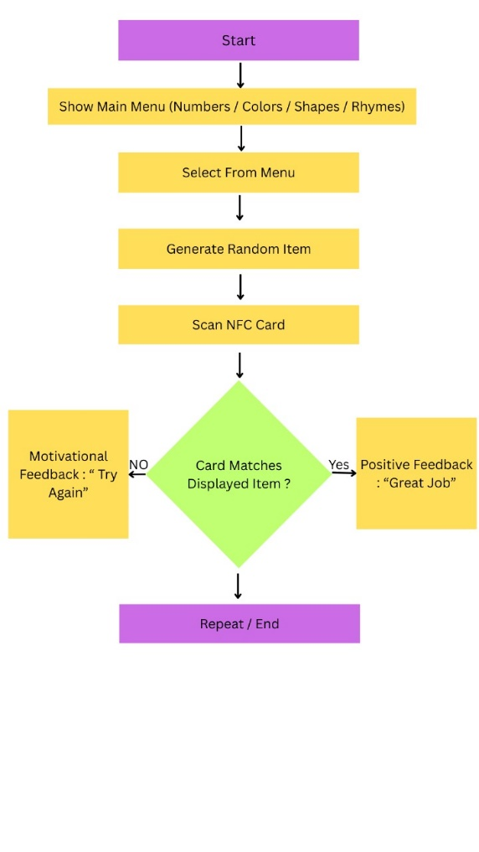

Fig. 1

1. Hardware and Software Components
2. Hardware Components:

* Microcontroller: Arduino Mega 2560
* NFC Module: MFRC522 RFID/NFC reader
* Display: 2.4-inch TFT LCD (ILI9341 driver)
* Audio Output: Passive buzzer/speaker module
* Input Controls: Tactile buttons for navigation
* Power Supply: 5V USB or Li-ion battery with voltage regulator
* Other: Level shifter for interfacing with 3.3V and 5V components

1. Software Tools:

* Development Platform: Arduino IDE
* Programming Language: C/C++
* Libraries Used:

1. MFRC522 – For RFID/NFC card detection and communication.
2. Adafruit_GFX & Adafruit_ILI9341 – For controlling the TFT display and rendering visual elements.
3. TMRpcm or custom PWM logic – For generating audio feedback through speaker output.
4. SoftwareSerial & DFRobotDFPlayerMini – For managing MP3 audio playback if using a DFPlayer Mini module.

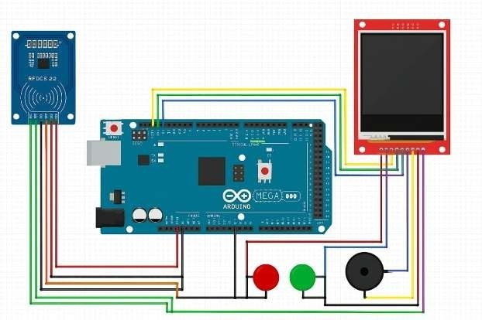

Fig.2

1. System Implementation

This section outlines how the prototype was built, integrating both hardware components and the software logic that governs the interactive functionality of the device.

1. Hardware Integration

The hardware setup includes an RFID (MFRC522) reader, a 2.4-inch TFT LCD display (ILI9341), tactile push buttons, and a speaker module. To avoid conflicts between devices using the SPI communication protocol, the RFID module is connected via the microcontroller’s default SPI interface, while the TFT display uses a software-defined SPI configuration. This dual SPI setup ensures smooth and independent operation of both components.

Tactile push buttons are incorporated to navigate the user interface, enabling selection and confirmation of menu options. The speaker provides audio feedback to enhance engagement and motivation. Power is supplied via USB or a battery with appropriate regulation to ensure stable operation.

1. Software Implementation

The software logic for the NFC-based educational device is developed using the Arduino programming environment (C++), tailored to run on the Arduino Mega microcontroller. The implementation adopts a modular approach that aligns with the system’s interactive requirements, ensuring intuitive feedback, real-time response, and low latency.

The firmware integrates multiple peripherals, including the MFRC522 RFID reader, ILI9341 TFT LCD display, DFPlayer Mini MP3 module for audio playback, and tactile buttons for user interaction. These components are managed using dedicated software libraries such as Adafruit_GFX, Adafruit_ILI9341, MFRC522, and DFPlayer_Mini_Mp3.

The device operates through a menu-driven interface, with each menu item representing a learning activity: Numbers, Colors, Shapes, and Rhymes. The user navigates using LEFT and RIGHT buttons and confirms a selection with the SELECT button. Once an activity is initiated, a random value is displayed (e.g., number “3” or red color), and the system waits for the user to scan a corresponding NFC card. Card verification is performed by comparing the scanned UID against a predefined list of valid UIDs mapped to each category. The system provides immediate visual and auditory feedback indicating success or prompting retry attempts. A long press on the SELECT button returns the user to the main menu.

1. The following pseudocode illustrates the simplified logic implemented in the system:

Start:

- Turn on the system

- Show main menu

While the system is running:

- Use buttons to choose an activity (Numbers, Colors, etc.)

- Start the activity and show a random target

- Wait for the user to scan a card

- If the card is correct:

→ Show "Great Job"

→ Play happy sound

→ Show next target

- If the card is wrong:

→ Show "Try Again"

→ Play error sound

- Long press the button anytime to return to the main menu

1. LIMITATIONS

While the prototype demonstrated effective performance in interactive learning scenarios, a few limitations were observed that present opportunities for future enhancement:

1. Short RFID Range: The MFRC522 RFID reader used in the device offers a limited scanning distance of approximately 2–4 cm. Although functional, this range may pose challenges for children with fine motor skill difficulties. Future iterations may incorporate long-range RFID modules to improve accessibility.
2. Static UID Mappings: The current implementation uses hardcoded UID-to-content mappings for NFC cards. As a result, adding new content requires reprogramming the microcontroller. Incorporating a dynamic content management system or SD card-based configuration could address this limitation.
3. Lack of Voice Interaction: The system provides auditory feedback through pre-recorded audio, but it does not support voice recognition or spoken interaction. Adding speech-based features in future versions could further enrich user engagement and accessibility.
4. Single Language Support: At present, the interface operates in a single language, which may limit its effectiveness in multilingual learning environments. Future versions could integrate multilingual capabilities to broaden usability and inclusivity.
5. No Data Logging: The prototype does not currently record user activity or performance data, which could be valuable for monitoring learning progress. Adding basic data logging features or cloud synchronization could offer insightful analytics for parents and educators.
6. RESULT

The proposed interactive learning console was successfully implemented and tested with children having intellectual disabilities. During the initial phase (first 2 to 3 weeks), some students faced challenges in correctly placing the NFC cards on the reader due to limited motor coordination. However, with continued usage and familiarity, their interaction with the device improved significantly.

In the subsequent 3 to 4 weeks, a noticeable improvement was observed in the learners’ ability to recognize and match characters. On average, students were able to identify more than the typical 30 to 50 characters within a 30-minute session, demonstrating enhanced engagement and retention through the multisensory learning approach provided by the console.

|  |  |  |
| --- | --- | --- |
| Phase | Duration | Average Characters Identified (per 20 min session) |
| Before Implementation | Baseline (Pre-test) | 20-25 |
| Initial Use (Adjustment) | Weeks 1–3 | 10-20 |
| Post-Adaptation | Weeks 4–8 | 20-30 |

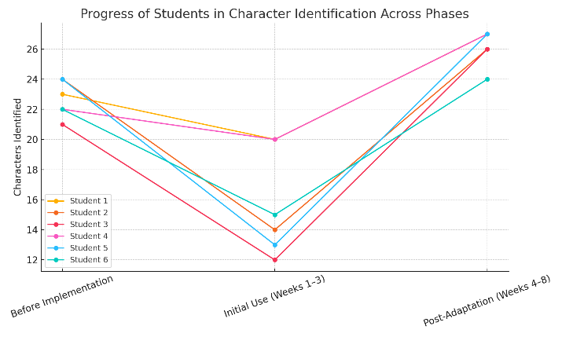

Fig. 3

1. CONCLUSION

The development and deployment of the proposed interactive learning console demonstrated significant potential in enhancing character recognition among children with intellectual disabilities. By integrating tactile interaction, visual stimuli, and auditory feedback, the system fostered a multisensory learning environment that helped bridge cognitive and motor challenges commonly observed in such learners.

Initial observations indicated a short adjustment period where performance slightly declined, likely due to unfamiliarity and coordination difficulties. However, continued usage over subsequent weeks resulted in a marked improvement in character identification accuracy and engagement levels. The results support the effectiveness of the console as a supportive educational tool that can complement traditional teaching methods.

Furthermore, the encouraging outcomes highlight the importance of accessible, technology-driven learning aids tailored to the needs of special education. Future enhancements, such as multilingual support, speech interaction, and cloud connectivity, can further expand the console's applicability and impact across diverse learning environments.

1. FUTURE WORK

To further enhance the educational impact and accessibility of the interactive learning console, several advancements are planned:

1. Future iterations of the console will include WiFi-based cloud connectivity to enable real-time tracking of student progress. A dedicated Learning Management System (LMS) will be developed to allow teachers, parents, and caregivers to monitor, assign, and customize learning activities remotely, fostering continuous support beyond the classroom.
2. To improve engagement and comprehension, the console will incorporate support for displaying images, emojis, and pictorial content. Image-based learning modules will be introduced to help children better understand abstract concepts through visual association.
3. The system will be enhanced with multilingual audio output to pronounce letters, numbers, and words displayed on the screen. This feature aims to make the console more inclusive and suitable for children from diverse linguistic backgrounds.

These enhancements are intended to make the console more interactive, personalized, and effective in delivering a meaningful learning experience tailored to the unique needs of children with intellectual disabilities.

# References

|  |  |
| --- | --- |
| [1] | N. G. D. A. S. R. A. L. Merlina Sari, "International Conference on Applied Science and Innovation (ICASI)," in *Proceedings of the International Conference on Applied Science and Innovation (ICASI)*, Medan, Indonesia, 2020. |
| [2] | N. H.-B. Kristian Stancin, "The Importance of Using Digital Games for Educational Purposes for Students with Intellectual Disabilities," in *International Scientific Conference on Innovative Approaches to the Application of Digital Technologies in Education (SLET-2020)*, Stavropol, Russia, 2020. |
| [3] | N. H.-B. S. S. M. Kristian Stančin, "Using Digital Game-Based Learning for Students with Intellectual Disabilities – A Systematic Literature Review," in *Vilnius University*, Rijeka, Croatia, 2020. |
| [4] | M. D. A. D. N. P.-Z. R. H. T. S. D. B. Ahmed Tlili, "Game-Based Learning for Learners With Disabilities—What Is Next? A Systematic Literature Review From the Activity Theory Perspective," 2022. |
| [5] | A. M. I. M. Dionysios Koulouris, "An IoT-Enabled Platform for the Assessment of Physical and Mental Activities Utilizing Augmented Reality Exergaming," *Sensors,* 2022. |
| [6] | A. D. F. R. D. F. A. R. C. R. Orazio Miglino, "Bridging Digital and Physical Educational Games Using RFID/NFC Technologies," *Journal of E-Learning and Knowledge Society,* 2014. |
| [7] | G. M. M. I. L. R. M. Á. G.-N. Pilar Castro Garrido, "Use of NFC-based Pervasive Games for Encouraging Learning and Student Motivation," in *Third International Workshop on Near Field Communication*, Hagenberg, Austria, 2011. |
| [8] | M. C. R. T. A. S. M. D. L. I. D. V. M. R. P. R. C. Jose A. Gallud, "Technology-enhanced and game based learning for children with special needs: a systematic mapping study," *Universal Access in the Information Society,* no. Springer, 2023. |
| [9] | C. R. D. Q. E. J. Katherine Valencia, "The Impact of Technology on People with Autism Spectrum Disorder: A Systematic Literature Review," *Sensors,* no. MDPI, 2019. |